**A Comprehensive Guide to Gradient Boosting Algorithm**

Gradient Boosting is one of the most powerful and popular machine learning algorithms, widely used for both classification and regression tasks. Its ability to create accurate predictive models by sequentially improving upon errors makes it a go-to choice in many industries, from finance to healthcare. In this blog, we will explore the working, key concepts, advantages, limitations, and applications of the Gradient Boosting algorithm.

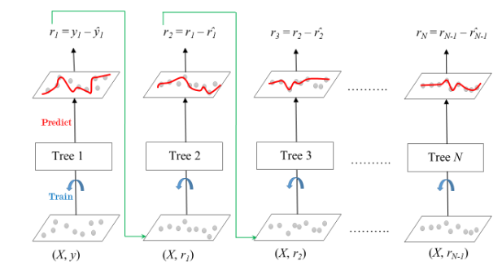

**What is Boosting?**

While studying machine learning, you must have encountered this term called boosting. It is the most misinterpreted term in the field of Data Science. The principle behind boosting algorithms is that first, we build a model on the training dataset; then, a second model is built to rectify the errors present in the first model. Let me explain to you what exactly this means and how this works.

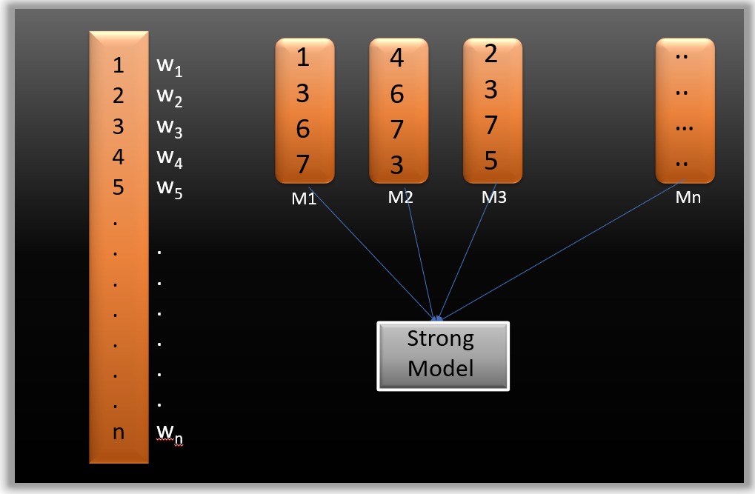

Suppose you have n data points and 2 output classes (0 and 1). You want to create a model to detect the class of the test data. Now we randomly select observations from the training dataset and feed them to model 1 (M1), assuming that initially, all observations carry equal weight, giving them an equal probability of selection.

Remember in ensembling techniques the weak learners combine to make a strong model so here M1, M2, M3….Mn, are all weak learners.

Since M1 is a weak learner, it will surely misclassify some observations. Now, before feeding the observations to M2, we update the weights of the wrongly classified observations. You can think of it as a bag that initially contains 10 different color balls, but after some time, some kid takes out his favorite color ball and puts 4 red color balls instead inside the bag. Of course, the probability of selecting a red ball is higher.

**What is Gradient Boosting?**

Gradient Boosting is an **ensemble learning technique** that builds models sequentially, with each model correcting the errors of its predecessor. Unlike bagging methods like Random Forest, which train multiple models in parallel, Gradient Boosting focuses on reducing the bias of the model by optimizing the residual errors using gradient descent. The result is a highly accurate predictive model.

**How Does Gradient Boosting Work?**

Gradient Boosting builds an ensemble of weak learners, typically decision trees, in an iterative manner. Here’s a step-by-step breakdown of how it works:

1. **Initialization**:
   * Start with an initial prediction, often the mean of the target variable for regression tasks or the logarithmic odds for classification tasks.
2. **Compute Residuals**:
   * Calculate the residuals (errors) by comparing the current model's predictions with the actual target values. These residuals represent the part of the data the current model failed to capture.
3. **Train a Weak Learner**:
   * Train a new weak learner (usually a shallow decision tree) to predict the residuals from the previous step.
4. **Update Predictions**:
   * Add the predictions from the new weak learner to the overall model prediction. A learning rate controls how much the new learner contributes to the overall prediction.
5. **Iterative Process**:
   * Repeat steps 2–4 for a specified number of iterations or until the error no longer improves significantly.
6. **Final Model**:
   * The final prediction is the sum of all weak learners’ predictions, weighted by their contributions (controlled by the learning rate).

**Key Concepts in Gradient Boosting**

1. **Weak Learners**:
   * Gradient Boosting typically uses decision trees as weak learners. These trees are shallow (e.g., depth = 3–5), making them fast to train and less prone to overfitting.
2. **Gradient Descent**:
   * Gradient Boosting minimizes the loss function by applying gradient descent. The residuals are used to approximate the negative gradient of the loss function, which guides the algorithm in the direction of improvement.
3. **Learning Rate**:
   * The learning rate (α) is a hyperparameter that determines the contribution of each weak learner to the final model. Smaller learning rates require more iterations but often lead to better results.
4. **Loss Function**:
   * Gradient Boosting optimizes a specified loss function, such as Mean Squared Error (MSE) for regression or Log-Loss for classification.
5. **Regularization**:
   * Techniques like limiting tree depth, subsampling the data, or adding a penalty to tree splits help prevent overfitting and improve generalization.

**Advantages of Gradient Boosting**

1. **High Accuracy**:
   * Gradient Boosting often outperforms other algorithms when tuned properly, especially on structured/tabular data.
2. **Flexibility**:
   * It supports custom loss functions, making it adaptable to a wide range of tasks.
3. **Feature Importance**:
   * Gradient Boosting provides insights into feature importance, which helps in understanding the drivers of the prediction.
4. **Handles Non-linear Data**:
   * Gradient Boosting effectively captures non-linear relationships between features and the target variable.

**Limitations of Gradient Boosting**

1. **Computationally Expensive**:
   * Since Gradient Boosting trains models sequentially, it is slower than parallelizable algorithms like Random Forest.
2. **Sensitive to Hyperparameters**:
   * The learning rate, number of iterations, and tree depth need careful tuning for optimal performance.
3. **Prone to Overfitting**:
   * Without proper regularization, Gradient Boosting can overfit on noisy data.
4. **Interpretability**:
   * While it provides feature importance, the overall model can be complex and less interpretable than simpler algorithms.

**Advanced Implementations**

Several libraries have been developed to optimize and extend Gradient Boosting, making it faster and more efficient:

1. **XGBoost (Extreme Gradient Boosting)**:
   * Optimized for speed and performance with features like regularization, parallel processing, and handling missing values.
2. **LightGBM (Light Gradient Boosting Machine)**:
   * Focuses on efficiency and scalability, particularly for large datasets. It uses a histogram-based approach to speed up training.
3. **CatBoost**:
   * Tailored for categorical features, with built-in handling of categorical variables and reduced need for preprocessing.

**Applications of Gradient Boosting**

1. **Finance**:
   * Credit risk modeling, fraud detection, and algorithmic trading.
2. **Healthcare**:
   * Disease diagnosis, patient risk assessment, and medical research.
3. **Marketing**:
   * Customer segmentation, churn prediction, and personalized recommendations.
4. **E-commerce**:
   * Price optimization, demand forecasting, and product recommendations.
5. **Energy**:
   * Load forecasting, energy price prediction, and renewable energy optimization.

**Tips for Tuning Gradient Boosting Models**

1. **Set the Learning Rate**:
   * Start with a small learning rate (e.g., 0.1) and increase the number of iterations.
2. **Control Tree Depth**:
   * Limit tree depth to prevent overfitting (e.g., depth = 3–5).
3. **Regularization**:
   * Use techniques like subsampling, early stopping, or adding penalties to improve generalization.
4. **Monitor Performance**:
   * Use cross-validation and evaluation metrics like AUC, accuracy, or RMSE to track the model’s performance.

**Conclusion**

Gradient Boosting is a versatile and powerful algorithm that forms the foundation of many advanced machine learning systems. Its ability to iteratively improve on errors, coupled with support for custom loss functions, makes it highly effective across a wide range of applications. While it requires careful tuning and can be computationally intensive, the results are often worth the effort. By leveraging advanced implementations like XGBoost, LightGBM, and CatBoost, you can harness the full potential of Gradient Boosting to solve complex real-world problems.

**Table: Differences Between Gradient Boosting and Random Forest**

| **Aspect** | **Gradient Boosting** | **Random Forest** |
| --- | --- | --- |
| **Algorithm Type** | Boosting: Models are built sequentially, with each model correcting the errors of the previous one. | Bagging: Models are built independently and in parallel, combining their results to reduce variance. |
| **Purpose** | Reduces bias by iteratively improving predictions. | Reduces variance by averaging predictions from multiple models. |
| **Training Process** | Sequential: Each weak learner depends on the output of the previous learner. | Parallel: All decision trees are built independently on different bootstrap samples. |
| **Base Models** | Typically uses weak learners, such as shallow decision trees. | Uses deep, fully grown decision trees as base models. |
| **Feature Selection** | Considers all features for splits but focuses on gradient optimization. | At each split, only a random subset of features is considered, reducing feature correlation. |
| **Learning Rate** | Includes a learning rate hyperparameter that controls how much each model contributes to the final prediction. | Does not use a learning rate. |
| **Handling Errors** | Focuses on correcting the residuals (errors) of the previous models, optimizing for a specific loss function. | Combines predictions from all trees using majority voting (classification) or averaging (regression). |
| **Overfitting** | More prone to overfitting if not properly regularized (e.g., using learning rate, early stopping). | Less prone to overfitting due to averaging across multiple trees. |
| **Speed** | Slower, as models are built sequentially and depend on the output of previous models. | Faster, as trees are built in parallel, leveraging multi-core processing. |
| **Scalability** | Advanced implementations (e.g., XGBoost, LightGBM) improve efficiency and scalability for large datasets. | Naturally scalable due to parallelism but may require more computational resources for larger forests. |
| **Interpretability** | Harder to interpret due to the sequential nature of model building. | Easier to interpret, as each decision tree can be analyzed independently. |
| **Tuning Complexity** | Requires careful tuning of learning rate, number of iterations, tree depth, and regularization parameters. | Easier to tune; the main parameters are the number of trees and tree depth. |
| **Performance on Small Data** | Often better for small datasets with proper tuning due to its focus on reducing bias. | Performs well on small datasets but may not capture complex patterns as effectively as Gradient Boosting. |
| **Handling Noisy Data** | Can struggle with noisy data, as it tries to fit residuals, which may include noise. | More robust to noise due to the averaging of multiple models. |
| **Loss Function** | Optimizes a specific loss function (e.g., Mean Squared Error, Log-Loss) via gradient descent. | Does not optimize a loss function directly but minimizes overall variance in predictions. |
| **Use Cases** | Best suited for scenarios where high accuracy is required, and time for hyperparameter tuning is available (e.g., Kaggle competitions, fraud detection). | Effective for general-purpose tasks and when interpretability, speed, or ease of use is more important (e.g., quick prototyping, baseline models). |